PRODUCT GROUP A : | Dell Desktop and Workstation (Commercial)
PRODUCT SUB GROUP : | OptiPlex Desktops ( Business Essentials )  Offices and workgroups needing an IT-friendly, reliable balance of performance and manageability.  - Business-class performance and control  - Scalable and durable design  - Designed specifically for networked environments
PRODUCT IMAGE : |  | PRODUCT NAME | New OptiPlex 3020 Micro
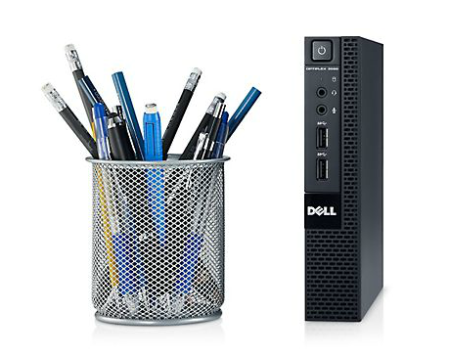 |  | PRODUCT PRICE ( RM ) | Contact Us
 |  | PRODUCT WEIGHT ( g ) | Refer to Product Details
 |  | PRODUCT DIMENSION (cm ) | Refer to Product Details
PRODUCT BRIEF DESCRIPTION :
Put mainstream performance anywhere you need it with the ultra-compact OptiPlex 3020 Micro Desktop and a complete range of custom mounts.

PRODUCT DETAIL DESCRIPTION :
Processor
Intel® Core™ i5 (4590T)
Intel® 4th Generation Intel® Core™ i3 (4150T)
Intel® Intel® Pentium® (G3240T)
Intel® Intel® Celeron® (G1840T)

Operating System
Windows® 7 Professional 32 bit (English) (EMRP)
Windows® 7 Professional 64 bit (English) (EMRP)
Windows 8.1 (64Bit) English
Windows 8.1 Pro (64Bit) English
Windows 8.1 Single Language (64Bit) English
Windows 7 Professional, English, 64bit (includes Windows 8.1 Pro 64bit License and Media)
Windows 7 Professional, English, 32bit (includes Windows 8.1 Pro 64bit License and Media)
No OS, Designed for Dell Wyse Cloud DT
Ubuntu Linux 12.04
Memory3
2GB (1 x 2GB) DDR3L 1600MHz Memory
4G (1x4GB) 1600MHz DDR3 Memory
8GB (1x8GB) 1600MHz DDR3L Memory

Chipset
Intel® H81 Chipset
Hard Drive
Up to 1000GB4 hard drive (5400RPM)
Up to 500GB4 SATA hard drive (7200RPM)
Up to 500GB4 Solid State Hybrid hard drive

Optical Drive
Supports optional optical disc drives by external USB or Optical Drive console.

Connectivity
Integrated Realtek® RTL8151GD Ethernet LAN 10/100/1000
Optional wireless M.2 802.11ac card

Micro
Dimensions (H x W x D) Inches/(cm) : 7.17 x 1.4 x 6.93 / 18.2 x 3.6 x 17.6
Min. Weight (lbs/kg) : 2.82 / 1.28
Number of Bays : 1 internal 2.5"
Expansion Slots : 1 M.2 (22x30mm)

Power Supply Unit :
Standard 65W adaptor. Minimum Efficiency >87%, ENERGY STAR compliant.

Ports, Slots & Chassis
I/O Ports
2 external USB 3.0 ports ( 1front ,1 rear) and 4 external USB 2.0 ports (1 front, 3 rear); 1 Serial port (optional); 2 PS/2 (optional); 1 RJ-45; 1 VGA; 1 DisplayPort 1.2; 1 Mic-in (front, re-taskable to headphone); 1 GHS (front);

Warranty
Limited Hardware Warranty9 ; Standard Next Business Day On Site Service after Remote Diagnosis10 (term varies by region); Optional 3-year Dell ProSupport™ for IT; 4 year and 5 year service and support options2

