PRODUCT GROUP A : | Dell Desktop and Workstation (Consumer)
PRODUCT SUB GROUP : | Alienware  For high-performance gaming. Fuel the epic win and enjoy the most immersive PC gaming experience anywhere. Choose from ultra-powerful desktops powered by high-end components.
PRODUCT IMAGE : |  | PRODUCT NAME | Alienware Area 51
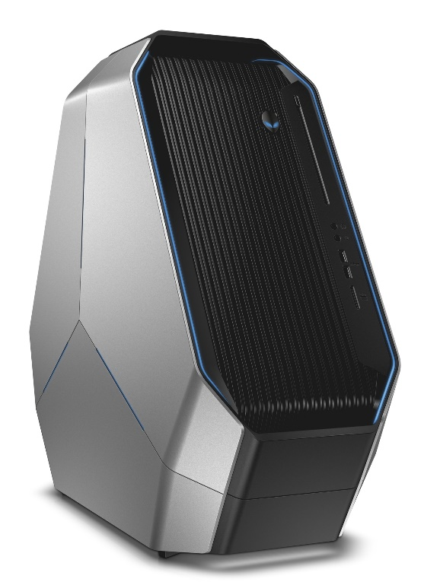 |  | PRODUCT PRICE ( RM ) | Contact Us
 |  | PRODUCT WEIGHT ( g ) | Refer to Product Details
 |  | PRODUCT DIMENSION (cm ) | Refer to Product Details
PRODUCT BRIEF DESCRIPTION :
Forget everything you know. With unprecedented gaming power and iconic, innovative design, the new Alienware Area-51 is the next evolution of high-performance desktop gaming.

PRODUCT DETAIL DESCRIPTION :
Processor
Intel® Core™ i7-5930K Processor (6-cores, 15MB Cache, Overclocked up to 3.9 GHz w/ Turbo Boost)
Intel® Core™ i7-5960X Processor (8-cores, 20MB Cache, Overclocked up to 4.0 GHz w/ Turbo Boost)

Operating System
Windows 8.1 Pro (64Bit) English
Windows 8.1 (64Bit) English
Windows 8.1 Single Language (64Bit) English
Windows 7 Professional SP1 64 bit (English)

Memory
16GB (4X4GB) DDR4 2133MHz SDRAM Memory
32GB (4X8GB) DDR4 2133MHz SDRAM Memory

Hard Drive
128GB SSD 6Gb/s Main + 2TB 7200RPM SATA 6Gb/s Storage
256GB SSD 6Gb/s Main + 4TB 6kRPM SATA 6Gb/s
Video Card
Dual NVIDIA® GeForce® GTX 970 with 8GB total (2x4GB) GDDR5 -NVIDIA SLI® Enabled
Triple NVIDIA® GeForce® GTX 970 with 12GB total (3x4GB) GDDR5 -NVIDIA SLI® Enabled

Optical Drive
Slot-Loading Dual Layer Blu-ray Reader (BR-ROM, DVD±RW, CD-RW)

Wireless
Intel® Dual Band Wireless-AC 7260 @ 5GHz + Bluetooth 4.0

Sound Card
Audio and Speakers, Internal High-Definition Audio via Creative Sound Core3D (Standard) (Standard)

Alienware Command Center
AlienFX™ exclusive lighting controls
AlienFusion advanced power management controls
AlienAdrenaline featuring:
- Game Mode custom game and application launcher
- Accelerator performance optimizer
- In-game and system Performance Monitoring
Thermal Controls
OC Controls

AlienFX Lighting Zones
Enhanced AlienFX System Lighting - 9 Lighting Zones
Internal Theater Lighting
Rear I/O Accessability Lighting

Chipset
Intel® X99 Express Chipset w/ Unlocked BIOS for Overclocking*, CPU Socket 2011

Color Options
Epic Silver

Motherboard
ATX Motherboard

Power
Alienware™ 850 Watt Multi-GPU Approved Power Supply
Alienware™ 1500 Watt Multi-GPU Approved Power Supply with modular cabling

Processor Cooling
Alienware Premium CPU Liquid Cooling

Warranty
1Yr ProSupport : Next Business Day Onsite Service w/Accidental Damage
Optional: 2, 3 Yr ProSupport : Next Business Day Onsite Service; 3 Yr Ltd Hardware Warranty, InHome Service after Remote Diagnosis W/Accidental Damage; 2, 3 Yr ProSupport : Next Business Day Onsite Service w/Accidental Damage

Chassis
I/O Ports:
Front: (2x) SuperSpeed USB 3.0; (1x) Microphone In; (1x) Headphone Out; (1x) Media Card Reader
Rear: (1x) RJ-45 Gigabit Ethernet; (4x) Hi-Speed USB 2.0; (4x) SuperSpeed USB 3.0; (1x) Microphone In; (1x) Line-In; (1x) Center/Subwoofer Speaker; (1x) Rear Left/Right Speakers; (1x) Side Left/Right Speakers; (1x) SPDIF Digital Output (TOSLINK); (1x) SPDIF Digital Output (Coax); (1x) Kensington Lock Security Port
Internal Expansion Slots: Slot 1: PCI-Express x16 Gen 32; Slot 2: PCI-Express x4 Gen 2; Slot 3: PCI-Express x16 Gen 32; Slot 4: PCI-Express x1 Gen 2; Slot 5: PCI-Express x16 Gen 32
Slots: Memory Slots 4x 288-Pin DDR4 UDIMM Slots

Alienware
Dimensions (H x W x D) Inches/(cm) : 22.4 x 10.7 x 25.1 /(56.9 x 27.2 x 63.8)
Min. Weight (lbs/kg) : 61.7 (28)

