PRODUCT GROUP A : | Dell Desktop and Workstation (Consumer)
PRODUCT SUB GROUP : | Alienware  For high-performance gaming. Fuel the epic win and enjoy the most immersive PC gaming experience anywhere. Choose from ultra-powerful desktops powered by high-end components.
PRODUCT IMAGE : |  | PRODUCT NAME | Alienware X51
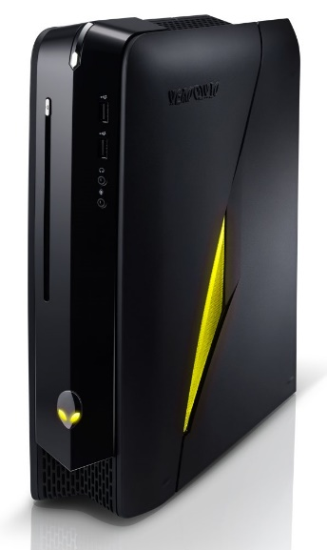 |  | PRODUCT PRICE ( RM ) | Contact Us
 |  | PRODUCT WEIGHT ( g ) | Refer to Product Details
 |  | PRODUCT DIMENSION (cm ) | Refer to Product Details
PRODUCT BRIEF DESCRIPTION :
Feel the thrill. Fill the room. This powerful desktop enables a full HD gaming experience on your big screen TV and is compact enough to fit on your desk.

PRODUCT DETAIL DESCRIPTION :
Processor
4th Generation Intel® Core™ i7-4790K processor (8M Cache, up to 4.40 GHz)
4th Generation Intel® Core™ i7-4790 processor (8MB Cache, up to 4.0GHz)
4th Generation Intel® Core™ i5-4460 processor (6MB Cache, up to 3.4GHz)

Operating System
Windows 8.1 Pro (64Bit) English
Windows 8.1 (64Bit) English

Memory
8GB Dual Channel DDR3 at 1600Mhz (2x4GB)
16GB Dual Channel DDR3 at 1600Mhz (2x8GB)

Hard Drive
1TB 7200 RPM SATA 6Gb/s
2TB 7200 RPM SATA 6Gb/s
256GB SSD SATA 6Gb/s + 1TB 5400RPM SATA 3Gb/s

Video Card
NVIDIA® GeForce® GTX 760Ti 2GB GDDR5
AMD Radeon™ R9 270 with 2GB GDDR5
Optical Drive
Slot-Loading Dual Layer DVD Burner (DVD±RW, CD-RW) (Standard)
Slot-Loading Dual Layer Blu-ray Reader (BR-ROM, DVD±RW, CD-RW)

Networking and Wireless
Dell Wireless 1550 (2x2 11ac combo with Bluetooth)

Color
AlienFX System Lighting - Nebula Aqua
AlienFX System Lighting - Blue
AlienFX System Lighting - Terra Green
AlienFX System Lighting - Plasma Purple
AlienFX System Lighting - Red
AlienFX System Lighting - Nova Yellow
Chasis Color :Matte Stealth Black with Dark Chrome Accents (Standard)

Sound Card
Audio and Speakers,Internal High-Definition 7.1 Performance Audio with WAVES MAXX Audio (Standard)

Chipset
Intel® H61 Express Chipset with 3rd Generation Processors (Standard)
Intel® H87 Express Chipset with 4th Generation Processors

Motherboard Class
Mini-ITX Motherboard

Power
Alienware™ 240 Watt Power Supply (Standard)
Alienware™ 330 Watt Power Supply

Processor Cooling
Alienware™ High-Performance Air Cooling

Software
Alienware Command Center
AlienFX™
AlienFusion
AlienAdrenaline

Warranty
1Yr ProSupport : Next Business Day Onsite Service w/Accidental Damage
Optional: 2, 3 Yr ProSupport : Next Business Day Onsite Service; 3 Yr Ltd Hardware Warranty, InHome Service after Remote Diagnosis W/Accidental Damage; 2, 3 Yr ProSupport : Next Business Day Onsite Service w/Accidental Damage

Chassis
I/O Ports:
Front: (2x) SuperSpeed USB 3.0; (1x) Microphone In; (1x) Headphone/Speaker Out
Rear: (1x) On-board HDMI 1.4 Output; (1x) RJ-45 Gigabit Ethernet; (2x) Hi-Speed USB 3.0; (4x) SuperSpeed USB 3.0; (1x) Front Left/Right Speakers; (1x) Center Speaker; (1x) Rear Left/Right Speakers; (1x) Side Left/Right Speakers; (1x) SPDIF Digital Output (TOSLINK) (1x) SPDIF Digital Output (Coax)
Internal Chassis Connections: (3x) SATA 6.0Gb/s Ports
Slots: Memory Slots 2x 240-Pin DDR3 SDRAM Slots

Alienware
Dimensions (H x W x D) Inches/(cm) : 13.5 x 3.7 x 12.5 /(34.3 x 9.5 x 31.8)
Min. Weight (lbs/kg) : 12.1 (5.49)

