PRODUCT GROUP A : | Dell Desktop and Workstation (Consumer)
PRODUCT SUB GROUP : | XPS  For the ultimate experience. From the thinnest all-in-ones to high-performance desktops, XPS stands for exceptional build quality, unique materials and powerful features.
PRODUCT IMAGE : |  | PRODUCT NAME | XPS 27 AIO
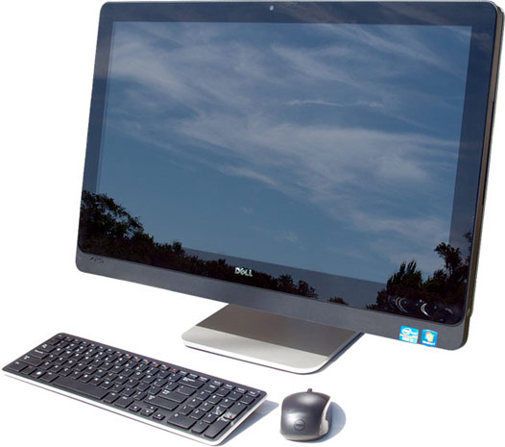 |  | PRODUCT PRICE ( RM ) | Contact Us
 |  | PRODUCT WEIGHT ( g ) | Refer to Product Details
 |  | PRODUCT DIMENSION (cm ) | Refer to Product Details
PRODUCT BRIEF DESCRIPTION :
See life in amazing color. Powered by 4th Gen Intel® Core™ processors and Windows 8.1 Single Language, our brightest and most versatile touch display features an Adobe RGB Quad-HD panel and articulating stand.

PRODUCT DETAIL DESCRIPTION :
Processor
4th Generation Intel® Core™ i5-4460 processor (6M Cache, up to 3.4 GHz)
4th Generation Intel® Core™ i7-4790 processor (8M Cache, up to 4.0 GHz)

Operating System
Windows 8.1 Pro (64Bit) English
Windows 8.1 Single Language (64Bit) English

Monitor
27 inch LED Backlit Touch Display with IPS and Adobe RGB QHD resolution (2560 X 1440)

Memory
8GB Dual Channel DDR3 1600MHz

Hard Drive
1TB 7200 rpm SATA 6Gb/s Hard Drive + 32GB mSATA Solid State Drive
2TB 7200 rpm SATA 6Gb/s Hard Drive + 32GB mSATA Solid State Drive

Video Card
NVIDIA GeForce GT 750M 2GB DDR5 with TPM V1.2 and Thunderbolt

Optical Drive
Slot-Loading Dual Layer DVD Burner (DVD±RW, CD-RW)

Networking and Wireless
Killer Wireless-N, 1202 for Video & Voice + Bluetooth 4.0

Sound Card
Waves MaxxAudio® Pro

Webcam
FHD (2.07MP) Integrated dual digital microphone array for Skype

Wired
10/100/1000 Gigabit

Warranty
1Yr ProSupport : Next Business Day Onsite Service w/Accidental Damage
Optional: 2, 3, 4 Yr Ltd Hardware Warranty, InHome Service after Remote Diagnosis; 2, 3, 4 Yr Carry-In Service after Remote Diagnosis; 2, 3, 4 Yr ProSupport : Next Business Day Onsite Service; 2, 3, 4 Yr Ltd Hardware Warranty, InHome Service after Remote Diagnosis W/Accidental Damage; 2, 3, 4 Yr ProSupport : Next Business Day Onsite Service w/Accidental Damage

Chassis
I/O Ports:
Rear:(4) USB 3.0, (1) RJ-45 10/100/1000, HDMI out, HDMI In
SIDE/Front Ports: Power button, Brightness adjust, HDD LED, 8:1 MCR, Microphone, phone jack, (2) USB3.0, ODD eject, Input select
Media Card Reader: 8:1 (supports SDXC (SD3.0), Secure Digital (SD), Multi Media Card (MMC), Memory Stick (MS), Memory Stick PRO, xD‐Picture Card, Hi Speed‐SD, Hi Capacity‐SD )
Slots: Memory Slots 2 DIMM slot

XPS
Dimensions (H x W x D) Inches/(cm) : 19.3 x 26.1 x 1.2-2.8 /(49.1 x 66.4 x 3.2-7.2)
Min. Weight (lbs/kg) : 35.16 (15.95)

