PRODUCT GROUP A : | Dell Desktop and Workstation (Consumer)
PRODUCT SUB GROUP : | XPS  For the ultimate experience. From the thinnest all-in-ones to high-performance desktops, XPS stands for exceptional build quality, unique materials and powerful features.
PRODUCT IMAGE : |  | PRODUCT NAME | XPS 8700
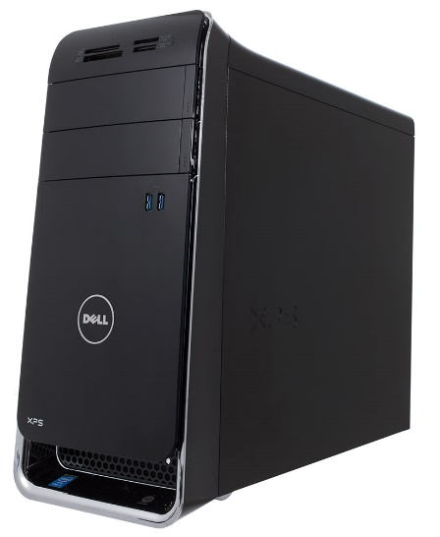 |  | PRODUCT PRICE ( RM ) | Contact Us
 |  | PRODUCT WEIGHT ( g ) | Refer to Product Details
 |  | PRODUCT DIMENSION (cm ) | Refer to Product Details
PRODUCT BRIEF DESCRIPTION :
Fully loaded. With room for more. Keep up with all your ideas using the fast 4th Gen Intel® Core™ processors, huge storage and easy expandability of this new desktop.

PRODUCT DETAIL DESCRIPTION :
Processor
4th Generation Intel® Core™ i5-4460 processor (6M Cache, up to 3.4 GHz)
4th Generation Intel® Core™ i7-4790 processor (8M Cache, up to 4.0 GHz)

Operating System
Windows 8.1 Pro (64Bit) English
Windows 8.1 Single Language (64Bit) English

Memory
8GB Dual Channel DDR3 1600MHz (4GBx2)
16GB Dual Channel DDR3 1600MHz - 4 DIMMs

Hard Drive
1TB 7200 RPM SATA Hard Drive 6.0 Gb/s
2TB 7200 RPM SATA Hard Drive 6.0 Gb/s

Video Card
NVIDIA® GeForce® GT 720 1GB DDR3
NVIDIA GeForce GTX 745 4GB DDR3

Optical Drive
16X CD/DVD burner (DVD+/-RW), write to CD/DVD
Networking and Wireless
Intel® Centrino® Advanced-N 6235 + Bluetooth 4.0
Dell Wireless-N 1703 @ 2.4GHz + Bluetooth 4.0

CPU Thermal
86W

Graphics Thermal
225W/150W/75W

Audio and Speakers
Integrated 7.1 Channel Audio with Waves MaxxAudio® Pro

Power
460W, optional 80 PLUS Bronze, 85% efficient, supply available on ENERGY STAR configurations

Warranty
1Yr ProSupport : Next Business Day Onsite Service w/Accidental Damage
Optional: 2, 3, 4 Yr Ltd Hardware Warranty, InHome Service after Remote Diagnosis; 2, 3, 4 Yr Carry-In Service after Remote Diagnosis; 2, 3, 4 Yr ProSupport : Next Business Day Onsite Service; 2, 3, 4 Yr Ltd Hardware Warranty, InHome Service after Remote Diagnosis W/Accidental Damage; 2, 3, 4 Yr ProSupport : Next Business Day Onsite Service w/Accidental Damage

Chassis
I/O Ports:
Bays: Support for 4 HDD bays: including (3) 3.5” HDDs; Capable of 1 SSD and 3 HDD configuration
Media Card Reader: 19-in-1 Card Reader (CF Type I, CF Type II, Micro drive, mini SD, MMC, MMC mobile, MMC plus, MS, MS Pro, MS Pro Duo, MS Duo, MS Pro-HG, RS-MMC, SD, SDHC Class 2, SDHC Class 4, SDHC Class 6, SM, xD)
Slots: Memory Slots 4 DIMM

XPS
Dimensions (H x W x D) Inches/(cm) : 16.0 x 7.3 x 17.5 /(40.6 x 18.5 x 44.4)
Min. Weight (lbs/kg) : 30.42 (13.8)

