PRODUCT GROUP A : | Dell Desktop and Workstation (Consumer)
PRODUCT SUB GROUP : | Inspiron 23 AIO series  For home and home office. Stay connected with computing that’s easy and inspiring. Whether it’s desktop or all-in-one, you can count on Inspiron to deliver exactly what you need.
PRODUCT IMAGE : |  | PRODUCT NAME | Inspiron 23 Series AIO Touch (2350)
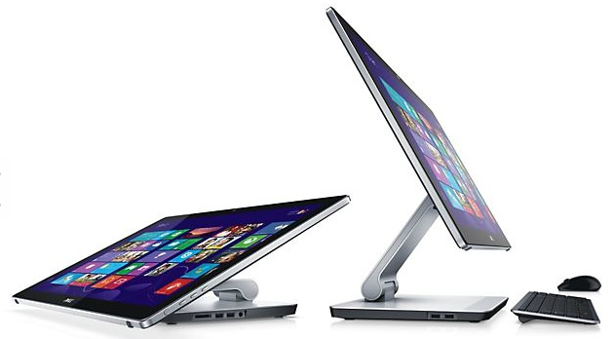 |  | PRODUCT PRICE ( RM ) | Contact Us
 |  | PRODUCT WEIGHT ( g ) | Refer to Product Details
 |  | PRODUCT DIMENSION (cm ) | Refer to Product Details
PRODUCT BRIEF DESCRIPTION :
Impressive from every angle. Simplify your space with our thinnest Inspiron all-in-one desktop, featuring an elegant design, adjustable stand and a Full HD (1080p) touch screen.

PRODUCT DETAIL DESCRIPTION :
Processor
4th Generation Intel® Core™ i7-4710MQ processor (6M Cache, up to 3.4 GHz)
4th Generation Intel® Core™ i5-4210M processor (3M Cache, up to 3.1GHz)

Operating System
Windows 8.1 Pro (64Bit) English
Windows 8.1 Single Language (64Bit) English

Monitor
23.0-inch FHD (1920 x 1080) Truelife LED-Backlit Touch Display with Wide Viewing Angle (IPS)

Memory
8GB Dual Channel DDR3 1600MHz - 2 DIMMs
12GB Dual Channel DDR3 1600MHz - 2 DIMMs

Hard Drive
1TB SATA Hard Drive + Intel SRT 32GB SSD Cache
1TB 5400rpm Hard Drive

Video Card
AMD Radeon HD 8690A with 2GB GDDR5 with 180W adapter
Intel HD Graphics with 150W adapter

Optical Drive
Supports optional optical disc drives by external USB or Optical Drive console.

Sound Card
HD Audio with Waves MaxxAudio, Integrated Basic Speakers

Wireless + Bluetooth
Dell Wireless 1705 802.11b/g/n, Bluetooth v4.0+LE

Camera
FHD Webcam w/ Mic; Integrated dual digital microphone array

Chipset
Intel® HM87 Express Chipset

Color Options
Black Front, Rear with Silver Trim, Base & Stand

Power
150 Watt AC Adaptor (Used with UMA/HD Graphics)
180 Watt AC Adaptor (Used with Discrete Graphics)

VESA Mount
No

Warranty
3 Yr Ltd Hardware Warranty, InHome Service after Remote Diagnosis / 3 Yr Carry-In Service after Remote Diagnosis
Optional: 4 Yr Ltd Hardware Warranty, InHome Service after Remote Diagnosis; 4 Yr Carry-In Service after Remote Diagnosis; 3, 4 Yr ProSupport: Next Business Day Onsite Service

Chassis
I/O Ports:
Side: 3x OSD keys, Power button, HDD LED
Stand (side): 4x USB 3.0; 8:1 MCR: MS/MS pro/MS pro hg/MS xc/SD/SDHC/SDXC/MMC; 1x Microphone/headphone jack
Stand (back): 1x Audio Line out: 1x RJ-45; 2x USB 2.0; HDMI in (1), HDMI out (1), DC in
TV Tuner: No TV Tuner
Slots: Memory Slots (2 SO DIMM Slots)

AIO (Touch) – without Stand
Dimensions (H x W x D) Inches/(cm) : 13.6 x 22.4 x 1.06 /(34.7 x 56.9 x 2.6)
Min. Weight (lbs/kg) : 15.76 ~ 15.99 (7.15 ~ 7.25)

Stand
Min. Weight (lbs/kg) : 2.34 ~ 3.04 (1.11 ~ 1.38)

