PRODUCT GROUP A : | Dell Laptops + Tablet
PRODUCT SUB GROUP A: | Alienware 13  For high-performance gaming. Fuel the epic win and enjoy the most immersive PC gaming experience anywhere. Choose from ultra-powerful notebooks powered by high-end technology
PRODUCT IMAGE : |  | PRODUCT NAME | Alienware 13
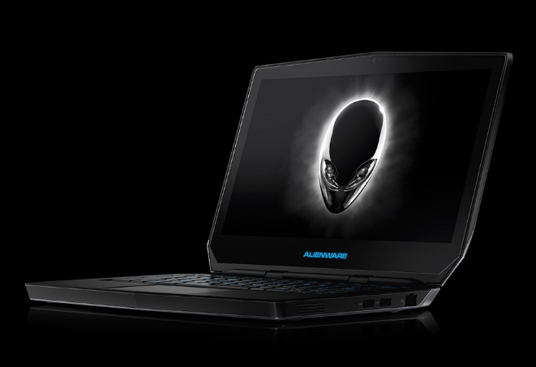 |  | PRODUCT PRICE ( RM ) | Contact Us
 |  | PRODUCT WEIGHT ( g ) | 2.05 kg
 |  | PRODUCT DIMENSION | 1.04” x 12.9” x 9.25”  (2.6 x 32.8 x 23.5 cm)
PRODUCT BRIEF DESCRIPTION :
Maximum mobility. Engineered for high-performance gaming anywhere, the Alienware 13 combines an incredibly mobile design with the ultimate at-home experience when plugged into the optional Graphics Amplifier.

PRODUCT DETAIL DESCRIPTION :
Processor
Intel® Core™ i5-4210U Processor (3M Cache, up to 2.70 GHz)

Operating System
Windows 8.1 Single Language (64Bit) English
Windows 8.1 Pro (64Bit) English
Windows(R) 7 Professional SP1 64bit (English)

Memory
8GB DDR3L at 1600MHz (2 x 4G)

Hard Drive
1TB (5.400 Rpm) Serial ATA Hard Drive
256GB Mobility Solid State Drive

Video Card
NVIDIA® GeForce® GTX 860M 2GB GDDR5

Optical Drive
Optical Drive not included
External Options only

Display
13 inch FHD (1920 x 1080) IPS-Panel Anti-Glare 350-nits Display
13 inch QHD (2560 x 1440) IPS-Panel TrueLife 400-nits Display with Touch Technology

Wireless
Killer 1525 802.11ac 2x2 WiFi and Bluetooth 4.1

Primary Battery
52 WHr, 4-Cell Battery

Camera
FullHD 2MP Camera with dual digital microphones

Audio and Speakers
Internal High-Definition Audio with Creative Soundblaster X-Fi MB3 Software (Standard)
2.0 Speaker configuration; ; Audio Powered by Klipsch®; 7.1 Digtial Audio out using HDMI out connection

A/C Adapter
130W

Keyboard
4-Zone, multi-color RGB, keyboard with AlienFX lighting controls

Port, Slot & Chassis
External Chassis Connections: (1x) Power/DC-in Jack; (1x) RJ-45 Gigabit Ethernet IPv6; (2x) SuperSpeed USB 3.0 Ports; (1x) SuperSpeed USB 3.0 Port with PowerShare Technology; (1x) Alienware Graphics Amplifier Port; (1x) Mini-Display Port; (1x) HDMI 1.4 Output; (1x) Audio Out 1/8" Ports (Compatible with inline mic headset); (1x) Line In Microphone 1/8" Port (retaskable for 5.1 analog audio output); (1x) Noble Lock port (cable and lock sold separately)
Memory Slots: 2x 204-Pin DDR3L SO-DIMM SDRAM Slots

Warranty & Services
1 Yr ProSupport: Next Business Day Onsite Service W/Accidental Damage
Optional: 2,3, 4 Yr Carry-In Service after Remote Diagnosis; 2, 3, 4 Yr ProSupport: Next Business Day Onsite Service; 2, 3, 4 Yr Ltd Hardware Warranty, InHome Service after Remote Diagnosis;4 Yr ProSupport : Next Business Day Onsite Service W/Accidental Damage; 2, 3, 4 Yr Carry-In Service after Remote Diagnosis W/Accidental Damage; 2, 3, 4 Yr Ltd Hardware Warranty, InHome Service after Remote Diagnosis W/Accidental Damage; 2, 3, 4Yr ProSupport : Next Business Day Onsite Service W/Accidental Damage

