PRODUCT GROUP A : | Dell Laptops + Tablet
PRODUCT SUB GROUP A: | Inspiron 3000 Series  For home and home office. Stay connected with computing that’s easy and inspiring. With this versatile family of laptops, you can count on Inspiron to deliver exactly what you need.
PRODUCT IMAGE : |  | PRODUCT NAME | Inspiron 11 3000 Series 2 in 1 (3147)
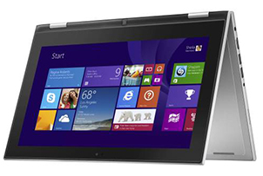 |  | PRODUCT PRICE ( RM ) | Contact Us
 |  | PRODUCT WEIGHT ( g ) | 1.39 Kg with HD touch screen
 |  | PRODUCT DIMENSION | 0.83” x 11.81” x 7.93”  (2.1 x 30.0 x 20.1cm)
PRODUCT BRIEF DESCRIPTION :
Two essential devices. One perfect package. With the performance of a laptop and versatility of a tablet, this 2-in-1 PC features Intel® processors, Windows 8.1 and an 11.6" touch screen

PRODUCT DETAIL DESCRIPTION :
Processor
Intel® Celeron® Processor N2840 (1M Cache, up to 2.58 GHz)
Intel® Pentium® Processor N3540 (2M Cache, up to 2.66 GHz)
4th Generation Intel® Core™ i3-4030U Processor (3M Cache, 1.90 GHz)

Operating System
Windows 8.1 Single Language (64Bit) English
Windows 8.1 Pro (64Bit) English
Windows 8.1 (64Bit) English

Memory
4GB DDR3L 1333MHz (4GBx1)

Hard Drive
500GB 5400RPM SATA Hard Drive

Video Card
Intel® HD Graphics

Optical Drive
Optical Drive not included
External Options only

Display
11.6 inch LED Backlit Touch IPS Display with Truelife, HD (1366 X 768)Trim options: Black

Wireless
Dell Wireless-N 1707 @ 2.4GHz + Bluetooth 4.0
Dell Wireless-N 1708 802.11bgn, 1x1, 2.4GHz + Bluetooth 4.0

Primary Battery
43 WHr, 3-Cell Battery (integrated)

Camera
HD (720p) capable webcam, dual digital microphones and pre-loaded Skype™2

Audio and Speakers
2 speakers with Waves MaxxAudio® Pro processing; 1 combo headphone / microphone jack

Software
My Dell, DropBox, Dell Digital Delivery, Dell Backup & Recovery, Microsoft® Office 2013 trial, McAfee LiveSafe (30day), Getting Started with Windows 8, Live Essentials (Movie Maker & Photo Gallery), Skype™2

A/C Adapter
65 Watt AC Adapter

Keyboard
Spill-resistant keyboard; Multi-Touchpad with integrated scrolling & gestures

Port, Slot & Chassis
HDMI™ 1.4a, Multi-media Card Reader, USB 3.0 (1), USB 2.0 (2), Security slot; Image Load, BIOS Customization, Hardware Customization, Asset Tagging and Reporting

Warranty & Services
1 Yr ProSupport: Next Business Day Onsite Service
Optional: 2,3, 4 Yr Carry-In Service after Remote Diagnosis; 2, 3, 4 Yr ProSupport: Next Business Day Onsite Service; 2, 3, 4 Yr Ltd Hardware Warranty, InHome Service after Remote Diagnosis;4 Yr ProSupport : Next Business Day Onsite Service W/Accidental Damage; 2, 3, 4 Yr Carry-In Service after Remote Diagnosis W/Accidental Damage; 2, 3, 4 Yr Ltd Hardware Warranty, InHome Service after Remote Diagnosis W/Accidental Damage; 1, 2, 3 Yr ProSupport : Next Business Day Onsite Service W/Accidental Damage

PRODUCT GROUP A : | Dell Laptops + Tablet
PRODUCT SUB GROUP A: | Inspiron 3000 Series  For home and home office. Stay connected with computing that’s easy and inspiring. With this versatile family of laptops, you can count on Inspiron to deliver exactly what you need.
PRODUCT IMAGE : |  | PRODUCT NAME | New Inspiron 14 3000 Series (3451)
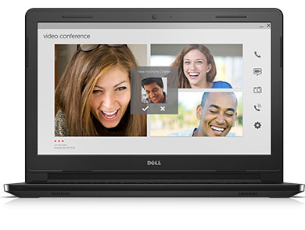 |  | PRODUCT PRICE ( RM ) | Contact Us
 |  | PRODUCT WEIGHT ( g ) | 1.77 Kg
 |  | PRODUCT DIMENSION | 0.84” x 13.58” x 9.57”  (2.1 x 34.5 x 24.3 cm)
PRODUCT BRIEF DESCRIPTION :
Everything you need for everything you do. Live, learn and share with the surprisingly affordable Inspiron 14 3000 Series laptops featuring the latest Intel® processors and long battery life.

PRODUCT DETAIL DESCRIPTION :
Processor
Intel® Pentium® Processor N3540 (2M Cache, up to 2.66 GHz)
4th Generation Intel® Core™ i3-4005U Processor (3M Cache, 1.70 GHz

Operating System
Windows 8.1 Single Language (64Bit) English
Windows 8.1 Pro (64Bit) English

Memory
4GB DDR3L 1333MHz (4GBx1)

Hard Drive
500GB 5400RPM SATA Hard Drive

Video Card
Intel® HD Graphics
NVIDIA® GeForce® 820M 2GB DDR3

Optical Drive
Optical Drive not included
External Options only
Display
14.0-inch HD (1366 x 768) Truelife LED-Backlit Display

Wireless
Dell Wireless-N 1707 @ 2.4GHz + Bluetooth 4.0
Intel® 3160AC + BT4.0 [802.11ac + Bluetooth 4.0, Dual Band 2.4&5 GHz, 1x1](Not for Indonesia)

Primary Battery
40 WHr, 4-Cell Battery (removable)

Camera
HD (720p) capable webcam, microphone

Audio and Speakers
2 tuned speakers with Waves MaxxAudio® processing; 1 combo headphone / microphone jack

A/C Adapter
45 Watt AC Adapter (w/standard graphics)
65 Watt AC Adapter (w/discrete graphics option)

Keyboard
Full size, spill-resistant keyboard

Touchpad
Multi-touch gesture-enabled pad with integrated scrolling

Port, Slot & Chassis
HDMITM 1.4a, USB 3.0 (1), USB 2.0 (2), Kensington lock slot, Media Card (SD, SDHC, SDXC)

Warranty & Services
1 Yr ProSupport: Next Business Day Onsite Service
Optional: 2,3, 4 Yr Carry-In Service after Remote Diagnosis; 2, 3, 4 Yr ProSupport: Next Business Day Onsite Service; 2, 3, 4 Yr Ltd Hardware Warranty, InHome Service after Remote Diagnosis;4 Yr ProSupport : Next Business Day Onsite Service W/Accidental Damage; 2, 3, 4 Yr Carry-In Service after Remote Diagnosis W/Accidental Damage; 2, 3, 4 Yr Ltd Hardware Warranty, InHome Service after Remote Diagnosis W/Accidental Damage; 1, 2, 3 Yr ProSupport : Next Business Day Onsite Service W/Accidental Damage

PRODUCT GROUP A : | Dell Laptops + Tablet
PRODUCT SUB GROUP A: | Inspiron 3000 Series  For home and home office. Stay connected with computing that’s easy and inspiring. With this versatile family of laptops, you can count on Inspiron to deliver exactly what you need.
PRODUCT IMAGE : |  | PRODUCT NAME | Inspiron 14 3000 Series with Optional Touch (3442)
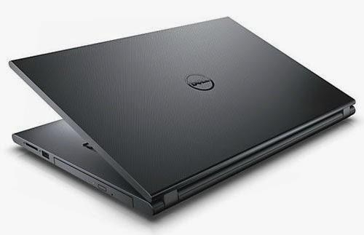 |  | PRODUCT PRICE ( RM ) | Contact Us
 |  | PRODUCT WEIGHT ( g ) | 2.02kg
 |  | PRODUCT DIMENSION | 1.0” x 13.6” x 9.7”  (2.5 x 34.6 x 24.6 cm)
PRODUCT BRIEF DESCRIPTION :
Perfect portability. An affordable 14" laptop packed with features for great performance on the go.

PRODUCT DETAIL DESCRIPTION :
Processor
Intel® Pentium® 3558U processor (2M Cache, 1.7GHz)
Intel® Celeron® Processor 3205U (2M Cache, 1.50 GHz)
4th Generation Intel® Core™ i3-4005U processor (3M Cache, 1.7GHz)

Operating System
Windows 8.1 Single Language (64Bit) English
Windows 8.1 Pro (64Bit) English
Windows® 8.1 Single Language with Bing

Memory
2GB Single Channel DDR3L 1600MHz (2GBx1)
4GB Single Channel DDR3L 1600MHz (4GBx1)

Hard Drive
500GB 5400RPM SATA Hard Drive

Video Card
Intel® HD Graphics

Optical Drive
Tray load DVD Drive (Reads and Writes to DVD/CD)
Display
14.0 inch LED Backlit Display with Truelife and HD resolution (1366 x 768)
14.0-inch HD (1366 x 768) Truelife LED-Backlit Display

Wireless
Dell Wireless-N 1705 @ 2.4GHz + Bluetooth 4.0

Primary Battery
40 WHr, 4-Cell Battery (removable)

Camera
HD (720p) capable webcam, microphone

Audio and Speakers
2 tuned speakers with Waves MaxxAudio® processing; 1 combo headphone / microphone jack

A/C Adapter
65 Watt AC Adapter

Keyboard
Full size, spill-resistant keyboard
(backlit version optional)

Touchpad
Multi-touch gesture-enabled pad with integrated scrolling

Port, Slot & Chassis
HDMI™ 1.4a, USB 3.0 (1), USB 2.0 (2), Security slot, Media Card (SD, SDHC, SDXC)

Warranty & Services
1 Yr ProSupport: Next Business Day Onsite Service
Optional: 2,3, 4 Yr Carry-In Service after Remote Diagnosis; 2, 3, 4 Yr ProSupport: Next Business Day Onsite Service; 2, 3, 4 Yr Ltd Hardware Warranty, InHome Service after Remote Diagnosis;4 Yr ProSupport : Next Business Day Onsite Service W/Accidental Damage; 2, 3, 4 Yr Carry-In Service after Remote Diagnosis W/Accidental Damage; 2, 3, 4 Yr Ltd Hardware Warranty, InHome Service after Remote Diagnosis W/Accidental Damage; 1, 2, 3 Yr ProSupport : Next Business Day Onsite Service W/Accidental Damage

PRODUCT GROUP A : | Dell Laptops + Tablet
PRODUCT SUB GROUP A: | Inspiron 3000 Series  For home and home office. Stay connected with computing that’s easy and inspiring. With this versatile family of laptops, you can count on Inspiron to deliver exactly what you need.
PRODUCT IMAGE : |  | PRODUCT NAME | Inspiron 15 3000 Series with Optional Touch (3542)
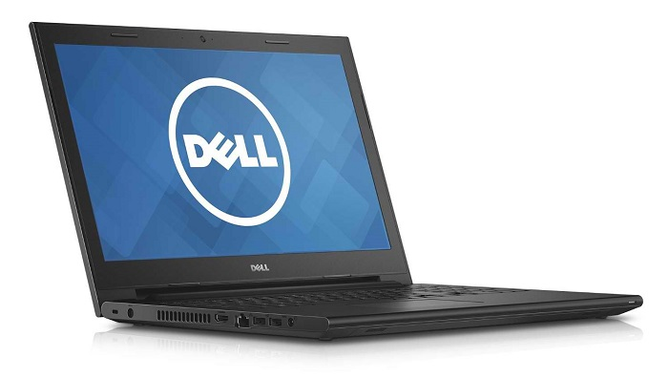 |  | PRODUCT PRICE ( RM ) | Contact Us
 |  | PRODUCT WEIGHT ( g ) | 2.37kg
 |  | PRODUCT DIMENSION | 1.04” x 15.0” x 10.1”  (2.6 x 38.1 x 27.6 cm)
PRODUCT BRIEF DESCRIPTION :
Big entertainment. Bold features. Get your hands on a versatile 15" laptop packed with features for an enjoyable multimedia experience. All at an affordable price.

PRODUCT DETAIL DESCRIPTION :
Processor
4th Generation Intel® Core™ i3-4005U Processor (3M Cache, 1.70 GHz)

Operating System
Windows 8.1 Single Language (64Bit) English
Windows 8.1 Pro (64Bit) English

Memory
4GB Single Channel DDR3L 1600MHz (4GBx1)

Hard Drive
500GB 5400RPM SATA Hard Drive

Video Card
Intel® HD Graphics
NVIDIA® GeForce® 820M 2GB DDR3L

Optical Drive
Tray load DVD Drive (Reads and Writes to DVD/CD)

Display
15.6 inch LED Backlit Display with Truelife and HD resolution (1366 x 768)

Wireless
Dell™ Wireless 1704 802.11b/g/n with Bluetooth v4.0
Dell Wireless-N 1705 @ 2.4GHz + Bluetooth 4.0

Primary Battery
40 WHr, 4-Cell Battery (removable)

Camera
HD (720p) capable webcam, microphone

Audio and Speakers
2 tuned speakers with Waves MaxxAudio® processing; 1 combo headphone / microphone jack

A/C Adapter
65 Watt AC Adapter

Keyboard
Full size, spill-resistant keyboard

Touchpad
Multi-touch gesture-enabled pad with integrated scrolling

Port, Slot & Chassis
HDMI™ 1.4a, USB 3.0 (1), USB 2.0 (2), Security slot, Media Card (SD, SDHC, SDXC)

Warranty & Services
1 Yr ProSupport: Next Business Day Onsite Service
Optional: 2,3, 4 Yr Carry-In Service after Remote Diagnosis; 2, 3, 4 Yr ProSupport: Next Business Day Onsite Service; 2, 3, 4 Yr Ltd Hardware Warranty, InHome Service after Remote Diagnosis;4 Yr ProSupport : Next Business Day Onsite Service W/Accidental Damage; 2, 3, 4 Yr Carry-In Service after Remote Diagnosis W/Accidental Damage; 2, 3, 4 Yr Ltd Hardware Warranty, InHome Service after Remote Diagnosis W/Accidental Damage; 1, 2, 3 Yr ProSupport : Next Business Day Onsite Service W/Accidental Damage

