PRODUCT GROUP A : | Dell Laptops + Tablet
PRODUCT SUB GROUP A: | Inspiron 5000 Series  For home and home office. Stay connected with computing that’s easy and inspiring. With this versatile family of laptops, you can count on Inspiron to deliver exactly what you need.
PRODUCT IMAGE : |  | PRODUCT NAME | Inspiron 14 5000 Series with Optional Touch (5447)
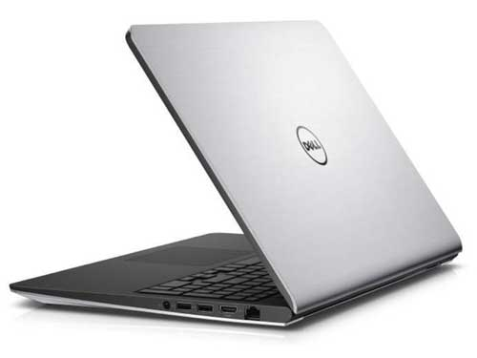 |  | PRODUCT PRICE ( RM ) | Contact Us
 |  | PRODUCT WEIGHT ( g ) | 2.02kg
 |  | PRODUCT DIMENSION | 0.9” x 13.5” x 9.7”  (2.1 x 34.2 x 24.6 cm)
PRODUCT BRIEF DESCRIPTION :
Long battery life to go a long way. Get around in style with a thin, lightweight and affordable 14" laptop featuring a vibrant HD screen and impressive battery life.

PRODUCT DETAIL DESCRIPTION :
Processor
5th Generation Intel® Core™ i5-5200U Processor (3M Cache, up to 2.70 GHz)
5th Generation Intel® Core™ i7-5500U Processor (4M Cache, up to 3.00 GHz)

Operating System
Windows 8.1 Single Language (64Bit) English
Windows 8.1 Pro (64Bit) English
Ubuntu Linux 14.04 SP1

Memory
4GB DDR3L 1333MHz (4GBx1)
8GB DDR3L 1600MHz (4GBx2)

Hard Drive
500GB 5400RPM SATA Hard Drive
1TB 5400 rpm Hybrid Hard Drive + 8GB Embedded Flash Cache
Video Card
AMD Radeon™ R7 M265 2GB DDR3
AMD Radeon™ R7 M270 4GB DDR3

Optical Drive
Optical Drive not included
External Options only

Display
14.0-inch HD (1366 x 768) Truelife LED-Backlit Display

Wireless
Intel® 3160AC + BT4.0 [802.11ac + Bluetooth 4.0, Dual Band 2.4&5 GHz, 1x1] (Except Indonesia)

Primary Battery
3 Cell 44 WHr Prismatic Battery (standard)
4 Cell 58 WHr Prismatic Battery (optional)

Camera
HD (720p) capable webcam, dual digital microphones and pre-loaded Skype™2

Audio and Speakers
2 speakers with Waves MaxxAudio® Pro processing; 1 combo headphone / microphone jack

A/C Adapter
65 Watt AC Adapter

Keyboard
Spill-resistant keyboard; Multi-Touchpad with integrated scrolling & gestures

Port, Slot & Chassis
HDMITM 1.4a, USB 3.0 (2), USB 2.0 (1), Security slot, Media Card (SD, SDHC, SD3.0, MS, MS Pro), 10/100 RJ-45 Ethernet network

Software
My Dell, Dropbox, PocketCloud, Dell Digital Delivery, Dell Backup & Recovery, Microsoft® Office 2013 trial, McAfee LiveSafe (30 day), Skype™2 , FastAccessTM Anywhere

Warranty & Services
2 Yr ProSupport: Next Business Day Onsite Service
Optional: 3, 4 Yr Carry-In Service after Remote Diagnosis; 3, 4 Yr ProSupport: Next Business Day Onsite Service; 3, 4 Yr Ltd Hardware Warranty, InHome Service after Remote Diagnosis;4 Yr ProSupport : Next Business Day Onsite Service W/Accidental Damage; 2, 3, 4 Yr Carry-In Service after Remote Diagnosis W/Accidental Damage; 2, 3, 4 Yr Ltd Hardware Warranty, InHome Service after Remote Diagnosis W/Accidental Damage; 1, 2, 3 Yr ProSupport : Next Business Day Onsite Service W/Accidental Damage

PRODUCT GROUP A : | Dell Laptops + Tablet
PRODUCT SUB GROUP A: | Inspiron 5000 Series  For home and home office. Stay connected with computing that’s easy and inspiring. With this versatile family of laptops, you can count on Inspiron to deliver exactly what you need.
PRODUCT IMAGE : |  | PRODUCT NAME | Inspiron 15 5000 Series (5547)
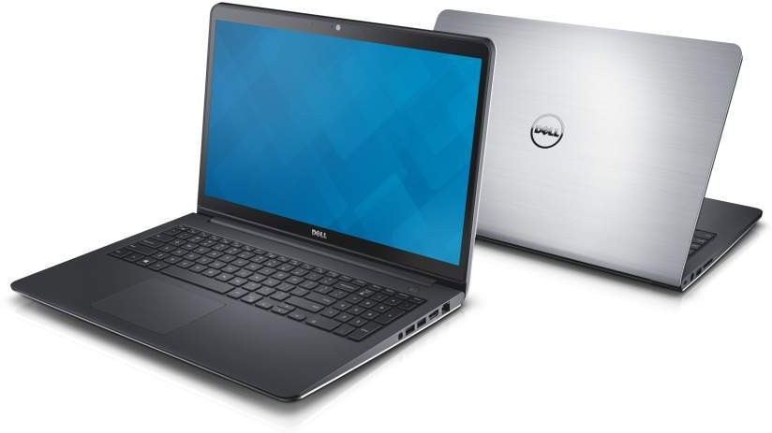 |  | PRODUCT PRICE ( RM ) | Contact Us
 |  | PRODUCT WEIGHT ( g ) | 2.38 Kg
 |  | PRODUCT DIMENSION | 0.9” x 14.9” x 10.0”  (2.1 x 38.0 x 25.9 cm)
PRODUCT BRIEF DESCRIPTION :
Versatile by design. Entertainment is always nearby with this sleek, lightweight and affordable 15.6" laptop featuring a vivid HD display.

PRODUCT DETAIL DESCRIPTION :
Processor
5th Generation Intel® Core™ i5-5200U Processor (3M Cache, up to 2.70 GHz)
5th Generation Intel® Core™ i7-5500U Processor (4M Cache, up to 3.00 GHz)

Operating System
Windows 8.1 Single Language (64Bit) English
Windows 8.1 Pro (64Bit) English
Ubuntu Linux 14.04 SP1

Memory
8GB Dual Channel DDR3L 1600MHz (4GBx2)

Hard Drive
1TB 5400RPM SATA Hard Drive
1TB 5400 rpm SATA Hybrid Hard Drive with 8GB Cache

Video Card
AMD Radeon™ R7 M265 2GB DDR3
AMD Radeon™ R7 M270 4GB DDR3

Optical Drive
Optical Drive not included
External Options only
Display
15.6-inch HD (1366 x 768) Truelife LED-Backlit Display

Wireless
Intel® 3160AC + BT4.0 [802.11ac + Bluetooth 4.0, Dual Band 2.4&5 GHz, 1x1](cannnot ship to Indonesia

Primary Battery
3 Cell 44 WHr Prismatic Battery (standard)
4 Cell 58 WHr Prismatic Battery (optional)

Camera
Integrated Widescreen HD 720P Webcam with Dual digital microphone array

Audio and Speakers
2 tuned speakers with Waves MaxxAudio® processing; 1 combo headphone / microphone jack

A/C Adapter
65 Watt AC Adapter

Keyboard
Full size, spill-resistant keyboard

Touchpad
Multi-touch gesture-enabled pad with integrated scrolling

Software
My Dell, Dropbox, PocketCloud, Dell Digital Delivery, Dell Backup & Recovery, Microsoft® Office 2013 trial, McAfee LiveSafe (30 day), Skype™2, FastAccess™ Anywhere

Port, Slot & Chassis
HDMI™ 1.4a, USB 3.0 (2), USB 2.0 (1), Security slot, Media Card (SD, SDHC, SD3.0, MS, MS Pro), 10/100 RJ-45 Ethernet network

Warranty & Services
2 Yr ProSupport: Next Business Day Onsite Service
Optional: 3, 4 Yr Carry-In Service after Remote Diagnosis; 3, 4 Yr ProSupport: Next Business Day Onsite Service; 3, 4 Yr Ltd Hardware Warranty, InHome Service after Remote Diagnosis;4 Yr ProSupport : Next Business Day Onsite Service W/Accidental Damage; 2, 3, 4 Yr Carry-In Service after Remote Diagnosis W/Accidental Damage; 2, 3, 4 Yr Ltd Hardware Warranty, InHome Service after Remote Diagnosis W/Accidental Damage; 1, 2, 3 Yr ProSupport : Next Business Day Onsite Service W/Accidental Damage

PRODUCT GROUP A : | Dell Laptops + Tablet
PRODUCT SUB GROUP A: | Inspiron 5000 Series  For home and home office. Stay connected with computing that’s easy and inspiring. With this versatile family of laptops, you can count on Inspiron to deliver exactly what you need.
PRODUCT IMAGE : |  | PRODUCT NAME | Inspiron 15 5000 Series with Optional Touch (5542)
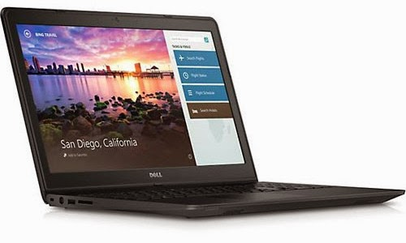 |  | PRODUCT PRICE ( RM ) | Contact Us
 |  | PRODUCT WEIGHT ( g ) | 2.02kg
 |  | PRODUCT DIMENSION | 1.0” x 13.6” x 9.7”  (2.5 x 34.6 x 24.6 cm)
PRODUCT BRIEF DESCRIPTION :
Built for versatility. This sleek, lightweight and affordable 15.6" laptop is packed with essential features and a vivid HD display for on-the-go entertainment.

PRODUCT DETAIL DESCRIPTION :
Processor
4th Generation Intel® Core™ i5-4210U processor (3M Cache, up to 2.7 GHz)

Operating System
Windows 8.1 Single Language (64Bit) English
Windows 8.1 Pro (64Bit) English
Ubuntu Linux 12.04 SP1

Memory
4GB Single Channel DDR3L 1600MHz (4GBx1)

Hard Drive
500GB 5400RPM SATA Hard Drive

Video Card
AMD Radeon™ HD R5 M240 2GB DDR3

Optical Drive
Optical Drive not included
External Options only

Display
15.6 inch LED Backlit Display with Truelife and HD resolution (1366 x 768)
LED Backlit Display with Truelife and HD resolution (1366 x 768)
LED Backlit Touch Display with HD resolution (1366 x 768)
LED Backlit Touch Display with FHD resolution (1920 x 1080)

Wireless
Intel® Dual Band Wireless-AC 3160 802.11ac, 1x1, 2.4 & 5GHz + Bluetooth 4.0

Primary Battery
Integrated prismatic 3-cell 43 WHr or 4-cell 58 WHr

Camera
HD (720p) capable webcam, dual digital microphones and pre-loaded Skype™2

Audio and Speakers
2 tuned speakers with Waves MaxxAudio® processing; 1 combo headphone / microphone jack

A/C Adapter
65 Watt AC Adapter

Keyboard
Full size, spill-resistant keyboard with 10-key numeric keypad

Touchpad
Multi-touch gesture-enabled pad with integrated scrolling

Software
My Dell, Dropbox, PocketCloud, Dell Digital Delivery, Dell Backup & Recovery, Microsoft® Office 2013 trial, McAfee LiveSafe (30 day)
Live Essentials (Movie Maker & Photo Gallery), Skype™2,Nuance Voice Recognition 1.5.x,FastAccess™ Anywhere

Port, Slot & Chassis
10/100 RJ-45 Ethernet network; 1 combo headphone / microphone jack; HDMI™ 1.4a, USB 3.0 (2), USB 2.0 (1), Security slot, Media Card (SD, SDHC, SD 3.0, MS, MS Pro)

Warranty & Services
2 Yr ProSupport: Next Business Day Onsite Service
Optional: 3, 4 Yr Carry-In Service after Remote Diagnosis; 3, 4 Yr ProSupport: Next Business Day Onsite Service; 3, 4 Yr Ltd Hardware Warranty, InHome Service after Remote Diagnosis;4 Yr ProSupport : Next Business Day Onsite Service W/Accidental Damage; 2, 3, 4 Yr Carry-In Service after Remote Diagnosis W/Accidental Damage; 2, 3, 4 Yr Ltd Hardware Warranty, InHome Service after Remote Diagnosis W/Accidental Damage; 1, 2, 3 Yr ProSupport : Next Business Day Onsite Service W/Accidental Damage

