PRODUCT GROUP A : | Dell Laptops + Tablet
PRODUCT SUB GROUP A: | Inspiron 7000 Series  For home and home office. Stay connected with computing that’s easy and inspiring. With this versatile family of laptops, you can count on Inspiron to deliver exactly what you need.
PRODUCT IMAGE : |  | PRODUCT NAME | Inspiron 13 7000 Series 2 in 1 (7347)
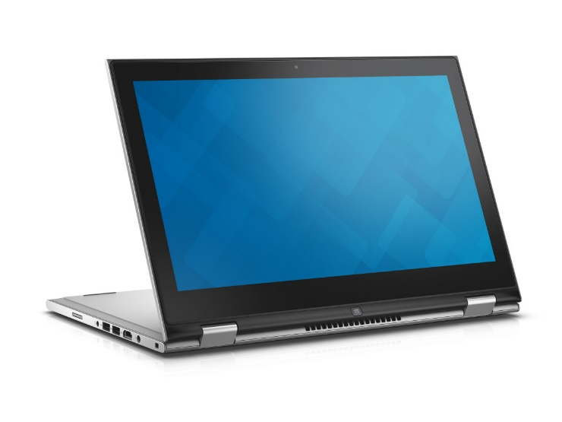 |  | PRODUCT PRICE ( RM ) | Contact Us
 |  | PRODUCT WEIGHT ( g ) | 3.66 kg
 |  | PRODUCT DIMENSION | 0.75” x 12.99” x 8.74”  (19.4 x 33.0 x 22.2 cm)
PRODUCT BRIEF DESCRIPTION :
Two powerful devices. One elegant design. The new Inspiron 13 7000 Series 2-in-1 combines the powerful performance of a premium laptop and the versatility of a 13.3" tablet with built-in stylus.

PRODUCT DETAIL DESCRIPTION :
Processor
4th Generation Intel® Core™ i3-4030U Processor (3M Cache, 1.90 GHz)
5th Generation Intel® Core™ i5-5200U Processor (3M Cache, up to 2.70 GHz)

Operating System
Windows 8.1 Single Language (64Bit) English
Windows 8.1 Pro (64Bit) English

Memory
4GB DDR3L 1333MHz (4GBx1)
8GB DDR3L 1600MHz (8GBx1)

Hard Drive
500GB 5400RPM SATA Hard Drive
500GB 5400 rpm Hybrid Hard Drive + 8GB Embedded Flash Cache
Video Card
Intel® HD Graphics 4400
Intel® HD Graphics 5500

Optical Drive
Optical Drive not included
External Options only

Display
13.3 inch LED Backlit Touch IPS Display with Truelife, HD (1366 X 768)
13.3-inch HD (1366 x 768) Truelife LED-Backlit Touch Display with Wide Viewing Angle (IPS)

Wireless
Dell Wireless-N 1707 802.11bgn, 1x1, 2.4GHz + Bluetooth 4.0
Dell Wireless-N 1708 802.11bgn, 1x1, 2.4GHz + Bluetooth 4.0
Intel® 7265AC + BT4.0 [802.11ac + Blueto

Primary Battery
43 WHr, 3-Cell Lithium-Ion Battery (removable)

Camera
HD (720p) capable webcam, dual digital microphones and pre-loaded Skype™2

Audio and Speakers
High Definition Audio with Waves MaxxAudio® Pro; 1 combo headphone / microphone jack

A/C Adapter
65 Watt AC Adapter

Keyboard
Spill-resistant keyboard; Multi-Touchpad with integrated scrolling & gestures

Port, Slot & Chassis
Full Size HDMI™ 1.4a, (2) USB 3.0 (One USB 3.0 w/Power Share), (1) USB 2.0, Security slot, Media Card (SD, MMC), (1) Passive Stylus (Standard), (1) combo headphone / microphone jack
Media Card Reader: 2-in-1 Media Card Reader: SD & MMC

Software
My Dell, Dropbox, Dell Digital Delivery, Dell Backup & Recovery, McAfee LiveSafe (30day), Live Essentials (Movie Maker & Photo Gallery), Skype™, FastAccess™

Warranty & Services
2 Yr ProSupport: Next Business Day Onsite Service
Optional: 3, 4 Yr Carry-In Service after Remote Diagnosis; 3, 4 Yr ProSupport: Next Business Day Onsite Service; 3, 4 Yr Ltd Hardware Warranty, InHome Service after Remote Diagnosis;4 Yr ProSupport : Next Business Day Onsite Service W/Accidental Damage; 2, 3, 4 Yr Carry-In Service after Remote Diagnosis W/Accidental Damage; 2, 3, 4 Yr Ltd Hardware Warranty, InHome Service after Remote Diagnosis W/Accidental Damage; 1, 2, 3 Yr ProSupport : Next Business Day Onsite Service W/Accidental Damage

PRODUCT GROUP A : | Dell Laptops + Tablet
PRODUCT SUB GROUP A: | Inspiron 7000 Series  For home and home office. Stay connected with computing that’s easy and inspiring. With this versatile family of laptops, you can count on Inspiron to deliver exactly what you need.
PRODUCT IMAGE : |  | PRODUCT NAME | Inspiron 14 7000 Series (7447)
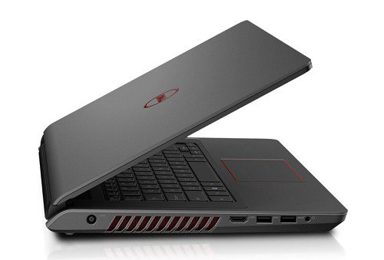 |  | PRODUCT PRICE ( RM ) | Contact Us
 |  | PRODUCT WEIGHT ( g ) | 2.12 Kg
 |  | PRODUCT DIMENSION | 1.02” x 13.64” x 9.74”  (2.6 x 34.6 x 24.7 cm)
PRODUCT BRIEF DESCRIPTION :
Powerful productivity. Powerful gaming. Supercharge work and play with a high-performance 14" laptop featuring the latest Intel® processors, NVIDIA® GeForce® GTX® graphics card and integrated subwoofer.

PRODUCT DETAIL DESCRIPTION :
Processor
4th Generation Intel® Core™ i5-4210H Processor (3M Cache, up to 3.50 GHz)
4th Generation Intel® Core™ i7-4710HQ Processor (6M Cache, up to 3.50 GHz)

Operating System
Windows 8.1 Single Language (64Bit) English
Windows 8.1 Pro (64Bit) English

Memory
4GB DDR3L 1600MHz (4GBx1)
8GB Dual Channel DDR3L 1600MHz (4GBx2)

Hard Drive
500GB 5400RPM SATA Hard Drive
1TB 5400 rpm SATA Hard Drive

Video Card
NVIDIA® GeForce® GTX 850M 4GB DDR3

Optical Drive
Tray load DVD Drive (Reads and Writes to DVD/CD)

Display
14.0 inch LED Backlit Display with Anti Glare and HD resolution (1366 x 768)

Wireless
Intel® Dual Band Wireless-AC 3160 802.11ac, 1x1, 2.4 & 5GHz + Bluetooth 4.0

Primary Battery
65 WHr, 6-Cell Battery

Camera
Integrated Widescreen HD Webcam with noise-canceling dual digital array microphones

Audio and Speakers
2 tuned speakers with Waves MaxxAudio® processing; 1 combo headphone / microphone jack

Port, Slot & Chassis
Externally Accessible: (2) USB 3.0 incl. 1 with PowerShare; (1) USB 2.0
HDMI™ v1.4a; Combination headphone/ microphone jackRJ45/Gigabit Ethernet 10/100/1000; Noble Security Lock; AC Power In
Multi-media Card Reader: Digital (SD) Memory Card; SD High-Capacity (SDHC) card; SD 3.0 Card

Warranty & Services
2 Yr ProSupport: Next Business Day Onsite Service
Optional: 3, 4 Yr Carry-In Service after Remote Diagnosis; 3, 4 Yr ProSupport: Next Business Day Onsite Service; 3, 4 Yr Ltd Hardware Warranty, InHome Service after Remote Diagnosis;4 Yr ProSupport : Next Business Day Onsite Service W/Accidental Damage; 2, 3, 4 Yr Carry-In Service after Remote Diagnosis W/Accidental Damage; 2, 3, 4 Yr Ltd Hardware Warranty, InHome Service after Remote Diagnosis W/Accidental Damage; 1, 2, 3 Yr ProSupport : Next Business Day Onsite Service W/Accidental Damage

PRODUCT GROUP A : | Dell Laptops + Tablet
PRODUCT SUB GROUP A: | Inspiron 7000 Series  For home and home office. Stay connected with computing that’s easy and inspiring. With this versatile family of laptops, you can count on Inspiron to deliver exactly what you need.
PRODUCT IMAGE : |  | PRODUCT NAME | Inspiron 15 7000 Series with Optional Touch (7537)
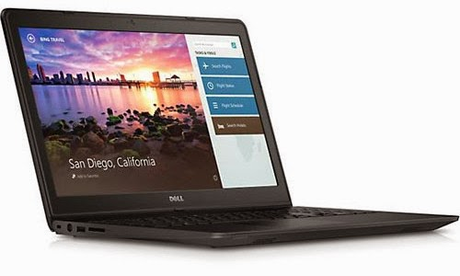 |  | PRODUCT PRICE ( RM ) | Contact Us
 |  | PRODUCT WEIGHT ( g ) | 2.6kg
 |  | PRODUCT DIMENSION | 0.8” x 14.9” x 10.0”  (2.1 x 37.9 x 25.4 cm)
PRODUCT BRIEF DESCRIPTION :
A feast for all your senses.4th Gen Intel® Core™ processors and Windows 8 complement a spacious 15.6" screen (with optional touch capability) and a forged aluminum design with diamond-cut beveled edges.

PRODUCT DETAIL DESCRIPTION :
Processor
4th Generation Intel® Core™ i5-4210U processor (3M Cache, up to 2.7 GHz)

Operating System
Windows 8.1 Single Language (64Bit) English
Windows 8.1 Pro (64Bit) English

Memory
6GB Dual Channel DDR3L 1600MHz (4GBx1 + 2GBx1)

Hard Drive
500GB 5400RPM SATA Hard Drive
1TB 5400RPM SATA Hard Drive

Video Card
Intel® HD Graphics 4400
NVIDIA® GeForce® GT 750M 2GB GDDR5

Optical Drive
Optical Drive not included
External Options only

Display
15.6 inch LED Backlit Display with Truelife and HD resolution (1366 x 768)

Wireless
Intel® Dual Band Wireless-N 7260 AGN @ 5GHz + Bluetooth 4.0

Primary Battery
58 WHr, 4-Cell Battery

Camera
Integrated 1.0MP Widescreen HD Webcam with noise-canceling dual digital array microphones

Audio and Speakers
Stereo speakers with Waves MaxxAudio® Pro processing; Built-in digital microphone

Keyboard
Dell(TM) Backlit Keyboard with Multi-Touch Touchpad with gesture support (English)

Port, Slot & Chassis
Externally Accessible: (4) USB 3.0 incl. 1 with PowerShare; RJ45 Ethernet; HDMI™ v1.4aCombination ; microphone jack; Kensington Security Lock; AC Power In
Multi-media Card Reader: Digital (SD) Memory Card; Secure Digital High Capacity (SDHC); Secure Digital Extended Capacity (SDXC) with UHS 50MB/Sec; Memory Stick (MS); Memory Stick PRO (MS Pro); Memory Stick XC (MSXC); Multi Media Card (MMC) - Multi Media Card plus (MMC+) supported in MMC compatibility mode only xD

Warranty & Services
1 Yr ProSupport: Next Business Day Onsite Service
Optional: 2,3, 4 Yr Carry-In Service after Remote Diagnosis; 2, 3, 4 Yr ProSupport: Next Business Day Onsite Service; 2, 3, 4 Yr Ltd Hardware Warranty, InHome Service after Remote Diagnosis;4 Yr ProSupport : Next Business Day Onsite Service W/Accidental Damage; 2, 3, 4 Yr Carry-In Service after Remote Diagnosis W/Accidental Damage; 2, 3, 4 Yr Ltd Hardware Warranty, InHome Service after Remote Diagnosis W/Accidental Damage; 1, 2, 3 Yr ProSupport : Next Business Day Onsite Service W/Accidental Damage

PRODUCT GROUP A : | Dell Laptops + Tablet
PRODUCT SUB GROUP A: | Inspiron 7000 Series  For home and home office. Stay connected with computing that’s easy and inspiring. With this versatile family of laptops, you can count on Inspiron to deliver exactly what you need.
PRODUCT IMAGE : |  | PRODUCT NAME | New Inspiron 15 7000 Series (7548)
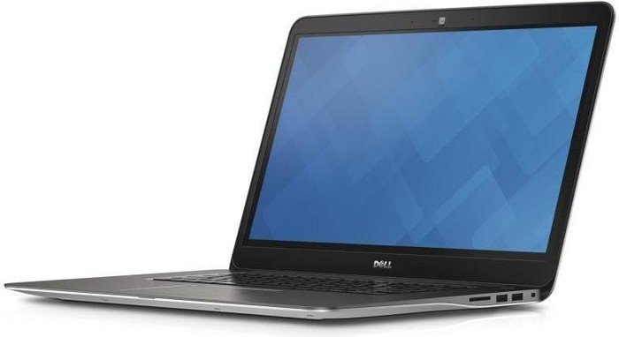 |  | PRODUCT PRICE ( RM ) | Contact Us
 |  | PRODUCT WEIGHT ( g ) | 2.11kg
 |  | PRODUCT DIMENSION | 14.8” x 0.7” x 10.3”  (37.7 X 1.9 X 26.1 cm)
PRODUCT BRIEF DESCRIPTION :
Complete clarity that’s simply stunning. 5th Gen Intel® Core™ processors, Windows 8.1 and an optional 4K Ultra HD display – the sharpest of any Inspiron – offer a truly impressive PC experience.

PRODUCT DETAIL DESCRIPTION :
Processor
5th Generation Intel® Core™ i5-5200U Processor (3M Cache, up to 2.70 GHz)
5th Generation Intel® Core™ i7-5500U Processor (4M Cache, up to 3.00 GHz)

Operating System
Windows 8.1 Single Language (64Bit) English
Windows 8.1 Pro (64Bit) English

Memory
8GB Dual Channel DDR3L 1600MHz (4GBx2)
16GB Dual Channel DDR3L 1600MHz (8GBx2)

Hard Drive
1TB 5400RPM SATA Hard Drive

Video Card
AMD Radeon™ R7 M270 4GB DDR3

Optical Drive
Optical Drive not included
External Options only

Display
15.6-inch HD (1366 x 768) Truelife LED-Backlit Touch Display
15.6-inch 4K Ultra HD (3840 x 2160) Truelife LED-Backlit Touch Display with Wide Viewing Angle (IPS)

Wireless
Intel® 3160AC + BT4.0 [802.11ac + Bluetooth 4.0, Dual Band 2.4&5 GHz, 1x1]

Primary Battery
43 WHr, 3-Cell Battery (integrated)
58 WHr, 4-Cell Battery (integraged)

Camera
Integrated 1.0MP Widescreen HD Webcam with noise-canceling dual digital array microphones

Audio and Speakers
Stereo speakers with Waves MaxxAudio® Pro processing; Built-in digital microphone

Keyboard
Dell(TM) Backlit Keyboard with Multi-Touch Touchpad with gesture support (English)

Port, Slot & Chassis
Externally Accessible: USB 3.0 with PowerShare (1), USB 3.0 (1), USB 2.0 (1) ; HDMI™ v1.4a; Combination headphone/ microphone jack; Noble Lock Slot; AC Power In
Multi-media Card Reader: Digital (SD) Memory Card; Secure Digital High Capacity (SDHC); Secure Digital Extended Capacity (SDXC)

Warranty & Services
2 Yr ProSupport: Next Business Day Onsite Service
Optional: 3, 4 Yr Carry-In Service after Remote Diagnosis; 3, 4 Yr ProSupport: Next Business Day Onsite Service; 3, 4 Yr Ltd Hardware Warranty, InHome Service after Remote Diagnosis;4 Yr ProSupport : Next Business Day Onsite Service W/Accidental Damage; 2, 3, 4 Yr Carry-In Service after Remote Diagnosis W/Accidental Damage; 2, 3, 4 Yr Ltd Hardware Warranty, InHome Service after Remote Diagnosis W/Accidental Damage; 1, 2, 3 Yr ProSupport : Next Business Day Onsite Service W/Accidental Damage

PRODUCT GROUP A : | Dell Laptops + Tablet
PRODUCT SUB GROUP A: | Inspiron 7000 Series  For home and home office. Stay connected with computing that’s easy and inspiring. With this versatile family of laptops, you can count on Inspiron to deliver exactly what you need.
PRODUCT IMAGE : |  | PRODUCT NAME | Inspiron 17 7000 Series (7746)
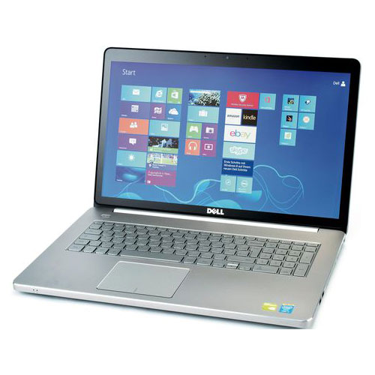 |  | PRODUCT PRICE ( RM ) | Contact Us
 |  | PRODUCT WEIGHT ( g ) | 3.29 kg
 |  | PRODUCT DIMENSION | 16.2” x 1.0” x 10.6”  (41.2 X 25.4 X 27.7 cm)
PRODUCT BRIEF DESCRIPTION :
The pinnacle of performance. Desktop power in a sleek, forged aluminium design sporting 5th Gen Intel® Core™ processors, Windows 8, an expansive 17.3" screen (with optional touch capability) and a built-in DVD.

PRODUCT DETAIL DESCRIPTION :
Processor
5th Generation Intel® Core™ i5-5200U Processor (3M Cache, up to 2.70 GHz)
5th Generation Intel® Core™ i7-5500U Processor (4M Cache, up to 3.00 GHz)

Operating System
Windows 8.1 Single Language (64Bit) English
Windows 8.1 Pro (64Bit) English

Memory
8GB Dual Channel DDR3L 1600MHz (4GBx2)
16GB Dual Channel DDR3L 1600MHz (8GBx2)

Hard Drive
1TB 5400 rpm Hybrid Hard Drive + 8GB Embedded Flash Cache

Video Card
NVIDIA® GeForce® 845M 2GB GDDR5

Optical Drive
Tray load DVD Drive (Reads and Writes to DVD/CD)

Display
17.3-inch FHD (1920 x 1080) Truelife LED-Backlit Touch Display

Wireless
Intel® 7265AC + BT4.0 [802.11ac + Bluetooth 4.0, Dual Band 2.4&5GHz, 2x2]

Primary Battery
58 WHr, 4-Cell Battery (integraged)

Camera
Integrated 1.0MP Widescreen HD Webcam with noise-canceling dual digital array microphones

Audio and Speakers
Stereo speakers with Waves MaxxAudio® Pro processing; Built-in digital microphone

Keyboard
Dell™ Backlit Keyboard with Multi-Touch Touchpad pad with gesture support (English)

Port, Slot & Chassis
Externally Accessible: (4) USB 3.0 incl. 1 with PowerShare ; RJ45 Ethernet; HDMI™ v1.4a; Combination headphone/ microphone jack; Kensington Security Lock; AC Power In
Multi-media Card Reader: Digital (SD) Memory Card; Secure Digital High Capacity (SDHC); Secure Digital Extended Capacity (SDXC) with UHS 50MB/Sec; Memory Stick (MS); Memory Stick PRO (MS Pro); Memory Stick XC (MSXC); Multi Media Card (MMC) - Multi Media Card plus (MMC+) supported

Warranty & Services
2 Yr ProSupport: Next Business Day Onsite Service
Optional: 3, 4 Yr Carry-In Service after Remote Diagnosis; 3, 4 Yr ProSupport: Next Business Day Onsite Service; 3, 4 Yr Ltd Hardware Warranty, InHome Service after Remote Diagnosis;4 Yr ProSupport : Next Business Day Onsite Service W/Accidental Damage; 2, 3, 4 Yr Carry-In Service after Remote Diagnosis W/Accidental Damage; 2, 3, 4 Yr Ltd Hardware Warranty, InHome Service after Remote Diagnosis W/Accidental Damage; 1, 2, 3 Yr ProSupport : Next Business Day Onsite Service W/Accidental Damage

