PRODUCT GROUP A : | Dell Laptops + Tablet
PRODUCT SUB GROUP A: | XPS 13  For the ultimate experience. XPS delivers the ultimate experience with the highest resolution displays, exceptional build quality, unique materials and powerful features.
PRODUCT IMAGE : |  | PRODUCT NAME | XPS 13 (9343)
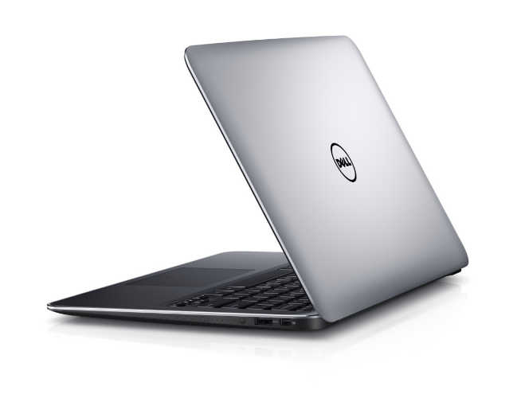 |  | PRODUCT PRICE ( RM ) | Contact Us
 |  | PRODUCT WEIGHT ( g ) | 1.18 kg
 |  | PRODUCT DIMENSION | 0.33” x 11.98” x 7.88”  (1.1 x 30.4 x 20.0 cm)
PRODUCT BRIEF DESCRIPTION :
Erase borders, starting with the display. The XPS 13 isn't just the smallest 13-inch laptop on the planet 1, it also has the world's first virtually borderless infinity display.

PRODUCT DETAIL DESCRIPTION :
Processor
I5th Generation Intel® Core™ i5-5200U Processor (3M Cache, up to 2.70 GHz)
5th Generation Intel® Core™ i7-5500U Processor (4M Cache, up to 3.00 GHz)

Operating System
Windows 8.1 Single Language (64Bit) English
Windows 8.1 Pro (64Bit) English

Memory
4GB Dual Channel DDR3L-RS 1600Mhz
8GB Dual Channel DDR3L-RS 1600Mhz

Hard Drive
128GB Solid State Drive
256GB Solid State Drive

Video Card
Intel® HD Graphics 5500

Optical Drive
Optical Drive not included
External Options only
Display
13.3-inch FHD (1920 x 1080) infinity display
13.3-inch UltraSharp™ QHD+ (3200 x 1800) infinity touch display

Wireless
DW 1560 + BT4.0 [802.11ac + Bluetooth 4.0, Dual Band 2.4&5 GHz, 2x2]

Primary Battery
52 WHr, 4-Cell Battery (integrated)

Camera
Widescreen HD (720p) webcam with dual array digital microphones

Audio and Speakers
Stereo speakers professionally tuned with Waves MaxxAudio® Pro 1W x 2 = 2W total

A/C Adapter
45W AC adapter

Keyboard
Full size, backlit chiclet keyboard; 1.3mm travel

Touchpad
Precision touchpad, seamless glass integrated button

Port, Slot & Chassis
2 USB 3.0, Powershare (1), mini DisplayPort (1), SD card reader, headset jack (1), Noble lock (1), 3-in-1 Card Reader (SD, SDHC, SDXC)
Exterior Chassis Materials: CNC machined aluminum; Edge-to-edge Corning® Gorilla® Glass NBT™ on QHD+; Carbon fiber composite palm rest with soft touch paint

Warranty & Services
1 Yr ProSupport: Next Business Day Onsite Service W/Accidental Damage
Optional: 2,3, 4 Yr Carry-In Service after Remote Diagnosis; 2, 3, 4 Yr ProSupport: Next Business Day Onsite Service; 2, 3, 4 Yr Ltd Hardware Warranty, InHome Service after Remote Diagnosis;4 Yr ProSupport : Next Business Day Onsite Service W/Accidental Damage; 2, 3, 4 Yr Carry-In Service after Remote Diagnosis W/Accidental Damage; 2, 3, 4 Yr Ltd Hardware Warranty, InHome Service after Remote Diagnosis W/Accidental Damage; 2, 3, 4Yr ProSupport : Next Business Day Onsite Service W/Accidental Damage

