PRODUCT GROUP A : | Dell Server
PRODUCT SUB GROUP : | Dell PowerEdge Tower Servers  Whether at home or a small office, the Dell PowerEdge Tower Servers are the perfect fit for your IT needs. See our range today.
PRODUCT IMAGE : |  | PRODUCT NAME | PowerEdge T20 Mini Tower Server
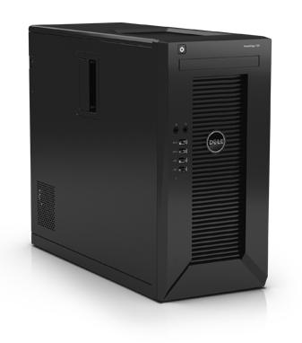 |  | PRODUCT PRICE ( RM ) | Contact Us
 |  | PRODUCT WEIGHT ( g ) | Refer to Product Details
 |  | PRODUCT DIMENSION (cm ) | Refer to Product Details
PRODUCT BRIEF DESCRIPTION :
Store, share and protect.
Boost collaboration in your home or small office with a quiet, compact server that helps all users get organized, share information more efficiently and become more productive

PRODUCT DETAIL DESCRIPTION :
Processor
1 processor from the following supported families:
Intel Xeon E3
Intel Pentium®

Operating System
Window Server 2008 R2, 2012, 2012 R2
RedHat 6.5

Chipset
C226

Memory
4 x UDIMM

Drive Bays
Up to six internal (cabled) hard drives in total:
Up to four 8.8cm (3.5) SATA hard drives, plus
Up to two 6.3cm (2.5) SATA hard drives (require expansion kits)

Slots
4 Slots,
1x16 (x16, G3)
1x16 (x4, G2)
1x1 (x1, G2)
1 x PCI Slot

Drive Controllers
Intel Rapid Storage Controller 12.X

RAID Controllers
Intel Rapid Storage Controller 12.X

Communications
1 Port ( Intel I217LM )

Power
290W

Availability
Error Correction Code (ECC) memory
Software RAID

Chassis
Mini Tower (Inch)
W 6.89
H 14.173
L 17.156

